|  |
| --- |
| **YEAR 12 Essentials Mathematics**  **Semester 2 2021**  **Longitude/Latitude & Time Zones** |
| Name: ______________________ Mark: ______ / 31 marks |
|  |

***Full working out must be shown to get full marks.***

***Attempt all questions***

***Resources allowed:***

***1 A4 page, (1 side) of hand written notes, ruler, calculator***

1. Use the map of the world to answer the following questions: (4 marks)

**B**

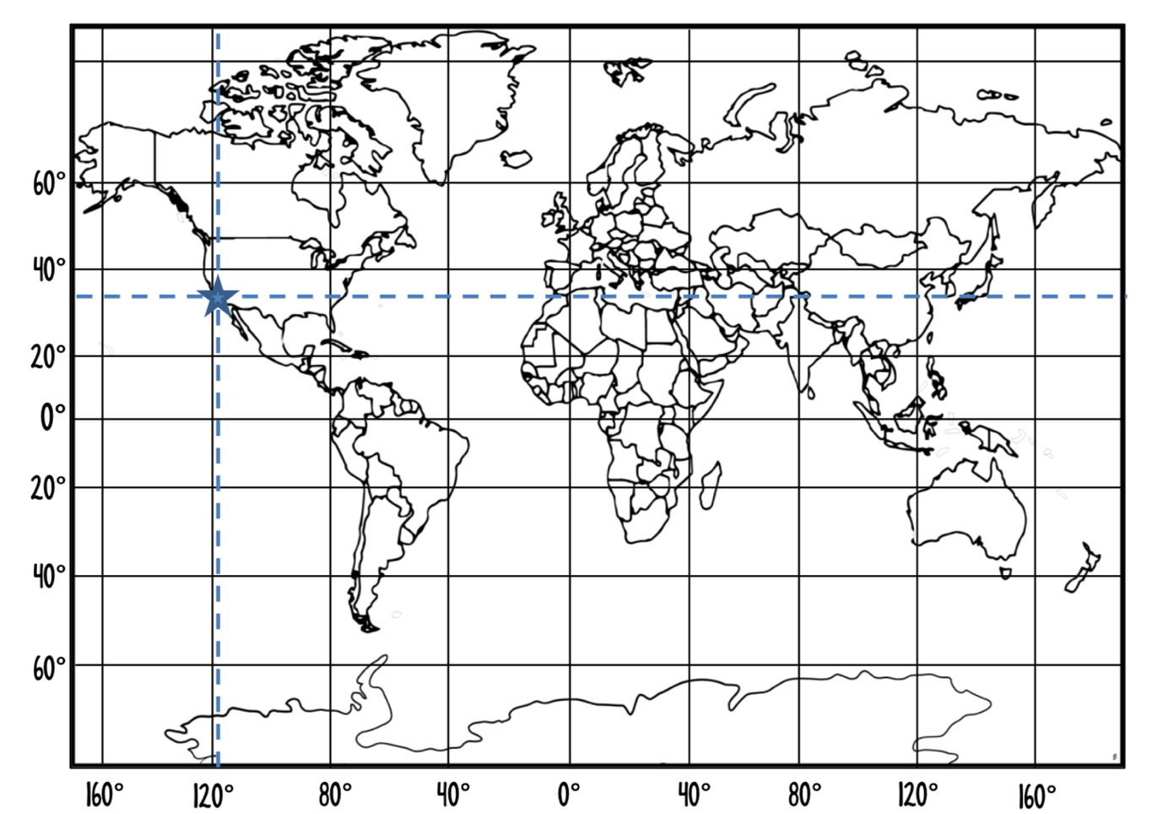

**A**

1. Name the significant line labeled A.__________________________________
2. Name the significant line labeled B.________________________________
3. Los Angeles is located on the map with a triangle. What are the coordinates of Los Angeles? ____________________________________________
4. South Africa is located on the map with a circle. What are the approximate coordinates of South Africa? ____________________________________________
5. Calculate the arc length (shown in bold) in the following circles (Answer in cm) (5 marks)
6. (b)

|  |  |
| --- | --- |
|  |  |

1. Find the **arc angle** between Bali (5°S, 115°E) and Mandurah (35°S, 115°E) correct to the nearest degree. (1 Mark)
2. *A* (23°N, 121°W) and *B* (65°N, 121°W) are two points on the surface of the Earth. Find the distance to the nearest kilometer between the points *A* and *B.*

(Approximate the radius of the Earth as 6 400km) (3 Marks)

1. Find the distance between Stockholm (59°N 18° E) and Cape Town (34°S 18°E) correct to the nearest kilometer.

(Approximate the radius of the Earth as 6 400 km) (3 Marks)

1. Using the Time Zones table below answer the following questions (4 Marks)

|  |  |
| --- | --- |
| **City** | **Time** |
| Sydney | GMT+10 |
| Melbourne | GMT+10 |
| Adelaide | GMT+9:30 |
| Perth | GMT+8 |
| Darwin | GMT+9:30 |
| Brisbane | GMT+10 |
| Hobart | GMT+10 |

* 1. If it is 3: 51 PM in Sydney, what time would it be in Darwin?

* 1. If it is 11:45 pm in Perth, what time would it be in Melbourne (considering daylight savings is in effect)?

1. Han, who is in Canberra (GMT +10) at the moment, has an interview over Skype with the human resources manager of an American trading firm scheduled for 3 pm on Monday, New York (GMT -5) time. (3 Marks)
2. Calculate the time difference between the two cities.
3. Find the time in Canberra when it is 3pm on Monday in New York.
4. What day will the interview fall on in Canberra?
5. An aircraft travels at an average speed of 913 km/h. It departs from a town in Kenya (0°, 38° E) on Tuesday at 10 pm and flies east to Borneo (0°, 113° E). (8 marks)
   1. What is the distance, to the nearest kilometre, between the two towns? (Assume the radius of the earth is 6400km)
   2. How long will the flight take? (Answer to the nearest hour)
   3. What will be the local time in Borneo when the aircraft arrives? (NOTE: Kenya is GMT+3 and Borneo is GMT+8)

END OF TEST